Riphah International University
Gulberg Green Campus Islamabad
Faculty of Computing (WISH)



Name: Anisha Rehmat.
Sap ID: 78019.
Submitted To: Mam Nayab Khalid
Submitted by: Anisha Rehmat.

Supervision and Coordination

Miss Shazwa Tun Naeem
Lecturer
Faculty of Computing

Lab Designers

Miss Nayab Khalid
Teaching Fellow
Faculty of Computing

Lab Task 3

Learning Outcomes:
• Java Introduction
• Take user input and display output in a Java program.
• Differentiate between instance, static, and local variables.
• Understand why variables belong to an object, a class, or a method.
• Understand the purpose of this keyword and use it correctly.
• Create private data members and access them through getters and setters.
• Apply encapsulation in a simple Java class.
• Create, run, and test Java programs in NetBeans.

LAB TASKS

Lab Task 1 – Student Information

Create a Student class with private name and age variables. Use setters to assign values and getters to display them. Take name and age from the user using Scanner. Requirements:
• Use private instance variables: name and age.
• Create setName(), setAge(), getName(), and getAge().
• Use this in the setter methods.
• Take input in main().
• Display the data using getters.

Code:-

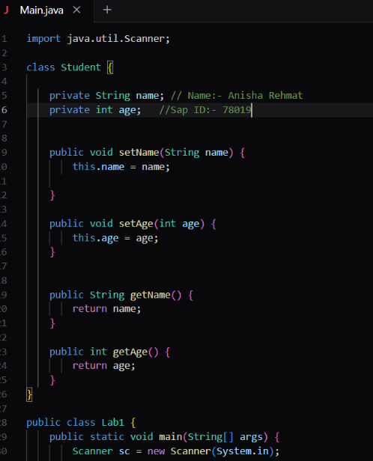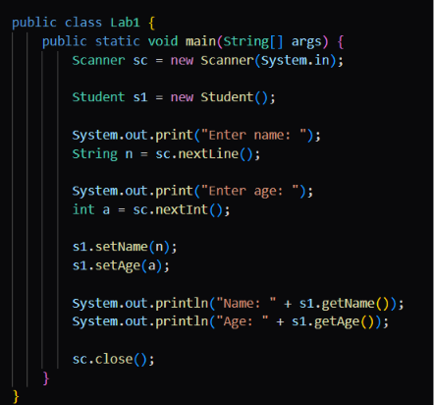

Output:-

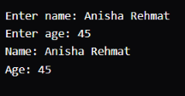

Lab Task 2 – Product Counter

Create a Product class with name, price, and quantity as private instance variables and totalProducts as a static variable.
• Create setters and getters for name, price, and quantity.
• Use this in all setters.
• Create two Product objects.
• Increase totalProducts whenever a product object is created or registered.
• Display both products and the total number of products.

Code:-

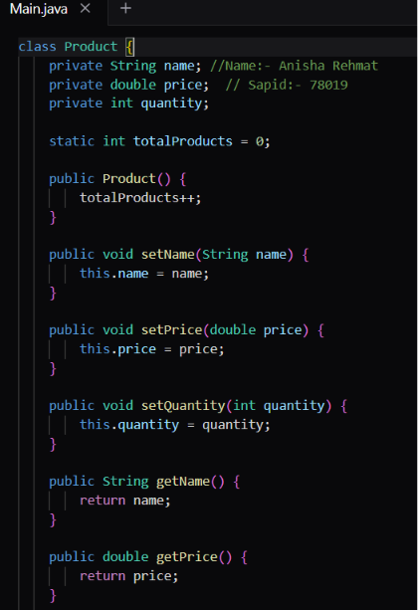

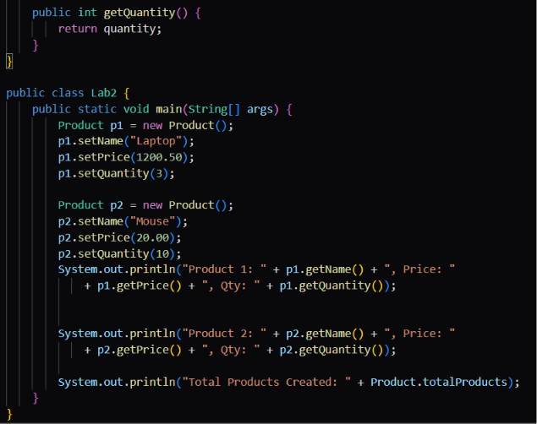

Output:-

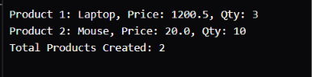

Lab Task 3 – Bank Account

Create a BankAccount class with accountHolder, accountNumber, and balance as private instance variables. Use getters and setters. Add a static totalAccounts variable.
• Take input for two bank accounts using Scanner.
• Set all values through setters.
• Display values through getters.
• Use a setter to prevent a negative balance.
• Display totalAccounts using the class name.

Code:-

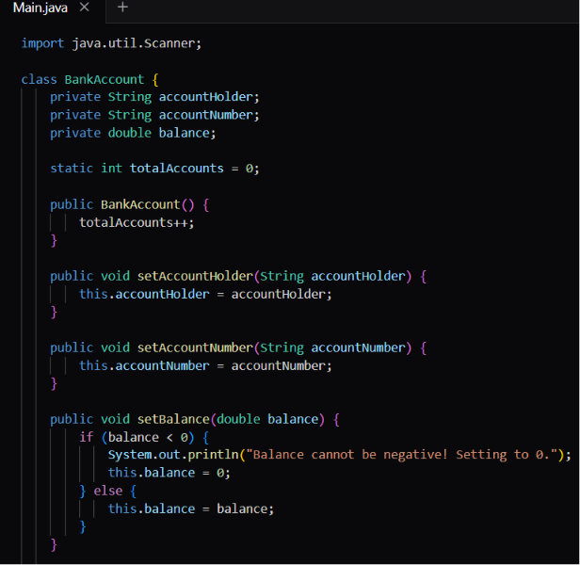

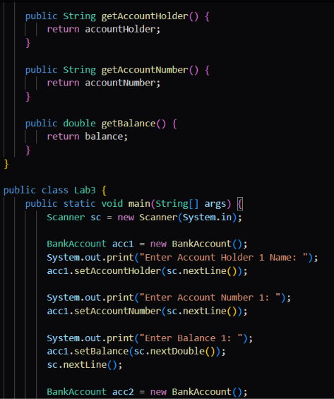

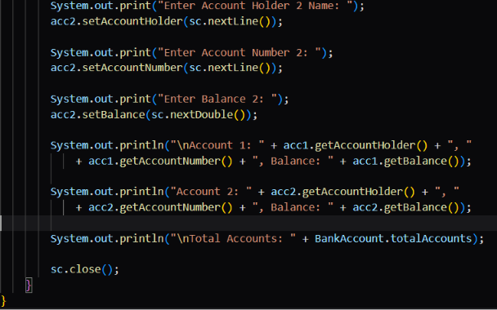
Output:-



